CHAPTER 1
INTRODUCTION
  - Overview of the Project

In the digital era, academic institutions rely heavily on technology for effective course management, student registration, and academic analytics. Traditional paper-based or Excel-based systems for handling student course registration often lead to inefficiency, manual errors, duplication, and data loss. The Online Course Registration – Pro Edition project has been developed to address these limitations through an interactive, lightweight, and fully client-side web application.
This system allows students to register for courses, check seat availability, and receive confirmation in real time. For administrators, it provides a centralized dashboard to manage courses, monitor enrollment, and analyze trends through visual reports and charts. It is designed as a Single Page Application (SPA) using HTML, CSS, and JavaScript, with LocalStorage used for data persistence, eliminating the need for a server-side database during development.
The system integrates real-time course validation, waitlist management, admin authentication, and data analytics for visualization of registration statistics. It is intended for both academic demonstration and real-world institutional use, providing scalability for future integration with server-based databases like PostgreSQL or MySQL.
The project demonstrates the integration of modern front-end technologies and data management concepts within a browser environment. It serves as a prototype that can later be adapted into an enterprise-grade course management platform.

  - Problem Statement

Managing student course registration manually often leads to challenges such as over-enrollment, duplicate entries, and lack of visibility for both students and administrators. Institutions using spreadsheets or offline systems face issues including:
- Difficulty in tracking available seats in real time.
- Absence of automated waitlist handling or conflict checks.
- Delayed updates and manual consolidation of course data.
- High risk of human error and lack of scalability.
The problem addressed by this project is therefore:
“How to design and implement an efficient, user-friendly, and fully client-side course registration system that enables real-time seat tracking, waitlist handling, and data analytics without requiring a server backend?”
This project aims to provide a practical, low-cost, browser-based solution that can simulate database operations and data analysis functionalities through JavaScript and web storage APIs.

  - Objectives of the Project

The major objectives of the Online Course Registration — Pro Edition project are as follows:
- To design and develop a responsive web-based course registration system using HTML, CSS, and JavaScript.
- To enable students to register for courses dynamically and check seat availability instantly.
- To implement admin functionalities for adding, editing, and deleting courses securely.
- To develop a waitlist and promotion logic that automatically updates registration when seats become available.
- To integrate client-side data storage using the LocalStorage API to simulate a database.
- To include data visualization modules (charts and graphs) for analyzing enrollment trends.
- To provide data export features (CSV/SQL) for record keeping and integration with other systems.
- To ensure security and integrity of administrative functions through SHA-256 hashed passwords.
- To design an intuitive, minimal, and accessible UI/UX that works across devices.
- To demonstrate integration of front-end development with database and analytics concepts for academic evaluation.

  - Scope of the Project

The scope of this project extends across multiple operational modules within an academic course registration ecosystem. It encompasses both student-side and admin-side functionalities, ensuring seamless interaction between the two ends of the system.
Functional Scope:
- Student registration and course selection interface.
- Seat count monitoring and real-time updates.
- Waitlist and auto-promotion system.
- Admin panel for course management and enrollment control.
- Analytics dashboard for visual representation of student enrollment (bar and pie charts).
- Export of course and student data to SQL/CSV for offline record maintenance.
Technical Scope:
- Fully client-side implementation using HTML, CSS, and JavaScript.
- LocalStorage and SessionStorage for maintaining persistent data without server dependency.
- Responsive UI design compatible with desktop and mobile browsers.
- Secure admin login system using SHA-256 password encryption.
- Structured, modular JavaScript codebase promoting reusability and scalability.
Out-of-Scope (for this version):
- Multi-user concurrent access (since data is stored locally).
- Cloud synchronization or backend integration (planned for future releases).
This project provides a demonstration platform for academic environments where simplicity, accessibility, and offline functionality are key advantages.

  - Methodology Adopted

The project follows a modular software development methodology, dividing the entire workflow into discrete, manageable phases to ensure systematic progress and integration.
- Requirement Analysis:
Identification of user needs, such as a browser-based registration form, admin dashboard, analytics features, and data storage structure.
- System Design:
Conceptualization of UI layout, navigation flow, LocalStorage schema (for courses and registrations), and waitlist logic.
Creation of architectural and data flow diagrams for better visualization of process interactions.
- Implementation:
Development of web pages and components using HTML, CSS, and JavaScript.
Integration of data handling and chart generation scripts for admin analytics.
- Testing and Validation:
Manual and automated tests conducted in different browsers (Chrome, Edge, Firefox) to verify responsiveness, data accuracy, and waitlist logic correctness.
- Evaluation and Refinement:
Optimization of script performance, UI improvements, and final validation of course registration workflows.
- Deployment:
Packaging the system as a single standalone HTML file (FINAL.html) that can run locally or be hosted on platforms such as GitHub Pages or Netlify.
This modular methodology ensures clear phase-wise progress, better maintainability, and a transparent workflow suitable for academic documentation.

CHAPTER 2
LITERATURE REVIEW

2.1 Review of Existing Systems
Course registration systems have evolved significantly from traditional manual approaches to modern web-based and cloud-driven solutions. Historically, academic institutions relied on paper-based registration or spreadsheet management, which involved long queues, manual data entry, and numerous human errors. Over time, universities and training platforms began adopting online systems, allowing students to select subjects and view schedules through web portals.
Existing systems can broadly be categorized into three types:
1. Manual / Paper-Based Registration Systems
These systems rely on physical forms, staff processing, and departmental approvals. They are simple but inefficient, with limited scalability and poor data traceability. Any change in student enrollment or course availability requires complete reprocessing.
2. Semi-Automated Systems
Many institutions moved to Excel or Google Sheets templates for recording student registrations. While this improved data organization, it still depended on manual updates and lacked validation mechanisms. Seat management and prerequisite checking had to be done manually, leading to potential errors and inconsistencies.
3. Fully Automated Online Portals
Modern systems such as Moodle, Blackboard, and CampusConnect introduced centralized, database-driven registration management. These systems provide real-time updates, user authentication, and integration with institutional databases. However, their high deployment and maintenance costs make them unsuitable for smaller colleges or academic projects.
The proposed Online Course Registration – Pro Edition combines the advantages of automation, simplicity, and offline usability using purely front-end technologies (HTML, CSS, and JavaScript). It eliminates the need for a dedicated backend, making it accessible for academic environments and small-scale educational institutions.
2.2 Limitations of Existing Systems
Despite advancements, existing course registration systems still suffer from several functional and operational constraints. Some of the key limitations are outlined below:
1. Manual Systems
- Lack of real-time seat availability tracking.
- High probability of human error and duplication.
- Difficult to update, analyze, or share data efficiently.
- Paper wastage and poor long-term data storage.
2. Spreadsheet-Based Systems
- No automated validation for prerequisites or scheduling conflicts.
- Absence of access control; data can be accidentally modified or deleted.
- Limited collaboration — only one user can effectively manage at a time.
- No built-in reporting or data visualization features.
3. Traditional Web-Based Systems
- Require database hosting and server-side scripting (e.g., PHP, MySQL).
- Setup and maintenance costs are high for educational prototypes.
- Lack of offline capability — users must always be online.
- Complexity in scaling or customizing for smaller institutions.

2.3 Proposed System Overview
The Online Course Registration – Pro Edition is designed to address the shortcomings of existing systems by offering a lightweight, secure, and fully client-side web solution. The system integrates front-end logic, local data storage, and analytical visualization to create a seamless course management workflow.
The proposed system follows five key design principles:
- Simplicity and Accessibility:
Implemented using standard web technologies — HTML, CSS, and JavaScript — to ensure quick deployment and compatibility across browsers. It runs entirely within a browser, requiring no external database or internet connectivity.
- Security and Privacy:
Administrative access is secured through a password hashed using the SHA-256 algorithm, ensuring that credentials are never stored in plain text.
- Data Integrity and Persistence:
Uses LocalStorage as a persistent client-side data store. All course, student, and waitlist information is retained even after the page is refreshed or reopened.
- Real-Time Interaction and Visualization:
Features instant updates when students register or seats fill up, accompanied by graphical analytics through charts (bar, pie, and line graphs).
- Extendability and Portability:
The modular codebase allows easy migration to a backend (e.g., Node.js + PostgreSQL) or integration with APIs for institutional databases in future enhancements.

2.4 Related Work and Technologies
Multiple academic and open-source projects have explored automated registration systems. Notable ones include:
- University of Toronto Online Enrollment Portal — a robust web-based system handling thousands of concurrent registrations.
- Google Forms-Based Enrollment Templates — simplified but lack data validation and analytics.
- LocalStorage-Powered JS Demos (GitHub Projects) — community prototypes that inspired the lightweight architecture used in this project.
Unlike most of these, the Pro Edition operates completely on the client-side, eliminating setup complexity. It blends front-end design, data persistence, and data visualization — all essential for demonstrating real-world database and analytics concepts within a browser.

2.5 Summary
The literature review establishes the gap between existing course management tools and the need for an academic-grade, easy-to-use, and offline-capable registration system.
While traditional solutions focus on enterprise-scale deployment, the proposed Pro Edition targets accessibility, educational use, and low-resource implementation — combining modern web technologies with intuitive analytics to create an all-in-one registration platform.

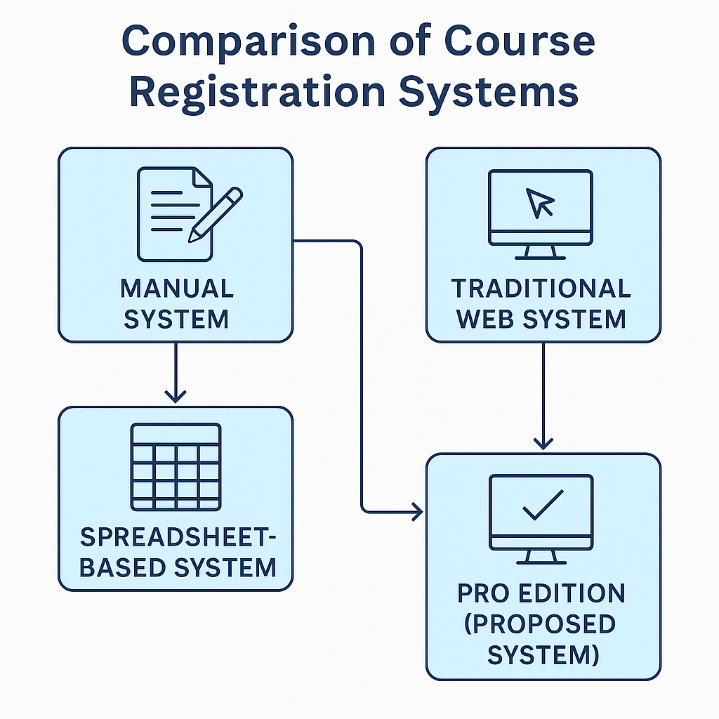
Fig.2.1 Comparison of course registration system

CHAPTER 3
SYSTEM ANALYSIS AND BACKGROUND
3.1 System Requirements:
System requirements define the hardware, software, and tools needed for implementing and running the Online Course Registration – Pro Edition. Since the project is entirely client-side, the setup is lightweight and platform-independent.
3.1.1 Software Requirements
Category | Specification
Operating System | Windows 10 or higher / macOS / Linux
Browser | Google Chrome, Mozilla Firefox, or Microsoft Edge
Front-End Languages | HTML5, CSS3, JavaScript (ES6+)
Libraries / APIs | CanvasJS or Chart.js for Analytics Charts, CryptoJS for password hashing
Database Simulation | LocalStorage / SessionStorage APIs

3.2 System Architecture
The Pro Edition follows a modular Client-Side Architecture, where all operations — from data validation to analytics — happen within the browser. This design ensures offline functionality and high responsiveness.
Architecture Layers:
- User Interface Layer
  - Built using HTML, CSS, and JS.
  - Students register, select courses, and view confirmations.
  - Admin manages courses and monitors analytics.
- Application Logic Layer
  - Contains all business logic for registration, validation, seat management, and waitlist handling.
  - Uses modular functions for CRUD operations on LocalStorage.
- Storage Layer
  - Utilizes the browser’s LocalStorage to maintain persistent data (courses, students, waitlist).
  - Data remains intact across sessions until explicitly cleared.
- Analytics Layer
  - Uses Chart.js or CanvasJS to display enrollment insights (e.g., number of students per course or mode of study).
Data Flow Summary:
- Student inputs registration data → JS logic validates and stores it in LocalStorage → Admin dashboard fetches data → Analytics visualizes trends.
3.3 Entity–Relationship (ER) Diagram
The ER Diagram represents logical data relationships between core entities stored in LocalStorage or exportable to an SQL schema.
Entities and Attributes
- Course
  - course_id (Primary Key)
  - course_name
  - course_code
  - total_seats
  - available_seats
  - mode (Online/Offline)
- Student
  - student_id (Primary Key)
  - name
  - email
  - selected_course_id (Foreign Key referencing Course)
  - registration_date
- Waitlist
  - waitlist_id (Primary Key)
  - student_id (Foreign Key referencing Student)
  - course_id (Foreign Key referencing Course)
  - priority_rank
- Admin
  - admin_id (Primary Key)
  - username
  - password_hash
Relationships
- One Course can have many Students.
- One Student can belong to one Course at a time.
- One Course may have multiple entries in Waitlist.
- Admin manages all CRUD operations for Course and Student entities.

3.4 Module Description
The system is divided into interdependent modules to promote modularity, scalability, and clarity during development.
1. Student Registration Module
- Handles registration form inputs and validation.
- Ensures no duplicate entries (unique email per course).
- Displays confirmation messages and updates course seat count.
2. Course Management Module
- Admin can add, edit, or delete course details.
- Tracks available seats, course codes, and delivery mode.
- Synchronizes changes dynamically with the registration interface.
3. Waitlist Module
- Automatically places students on a waitlist if seats are full.
- Implements priority-based promotion when a seat becomes available.
4. Admin Authentication Module
- Provides secure login using hashed credentials stored in LocalStorage.
- Restricts course modification and analytics access to authorized users only.
5. Analytics & Reporting Module
- Displays bar and pie charts for enrollment distribution.
- Allows export of course and student data to CSV or SQL format.

CHAPTER 4
IMPLEMENTATION
4.1 Tools and Technologies Used
Implementation of the Online Course Registration – Pro Edition system required a combination of web technologies, development tools, and libraries. The entire project was built using client-side scripting, enabling the system to operate without a backend or external database.
1. Front-End Development
- HTML5 Defines the structure and content of web pages.
- CSS3 Used for layout, color schemes, animations, and responsive styling.
- JavaScript (ES6) Implements the logic, event handling, and LocalStorage-based data management.
2. Data Management
- LocalStorage & SessionStorage APIs Browser-native mechanisms for persistent data storage without server dependency.
- JSON Objects Used for structured data representation (students, courses, waitlists).
3. Security
- CryptoJS (SHA-256) Ensures admin password hashing and secure login validation.
- Form Validation Prevents invalid or duplicate registrations.
4. Data Visualization
- Chart.js Generates bar and pie charts in the Admin dashboard to visualize enrollment patterns and course capacity distribution.
5. Development Tools
- Visual Studio Code Used as the primary IDE.
- GitHub For version control and source backup.
- Browser DevTools Debugging and testing console.
6. Deployment
- Hosted locally or optionally on GitHub Pages , Netlify, making it easy for demonstration or public access.
4.2 Module-Wise Implementation
This module enables students to register for courses by filling out a simple form that includes fields such as name, email, course selection, and mode (online/offline).
Functional Steps:
- Input validation ensures that no field is left blank.
- The system checks for duplicate entries using email as a unique key.
- Seat count is reduced automatically upon successful registration.
- If the course is full, the student is moved to the waitlist array.
Sample Code Snippet:
function registerStudent() {
const name = document.getElementById('name').value;
const email = document.getElementById('email').value;
const course = document.getElementById('course').value;
let registrations = JSON.parse(localStorage.getItem('registrations')) || [];
const existing = registrations.find(r => r.email === email && r.course === course);
if (existing) {
alert("You are already registered for this course!");
return;
}
let courseData = JSON.parse(localStorage.getItem('courses')) || [];
let selectedCourse = courseData.find(c => c.name === course);
if (selectedCourse.availableSeats > 0) {
selectedCourse.availableSeats--;
registrations.push({ name, email, course, status: 'Registered' });
alert("Registration successful!");
} else {
registrations.push({ name, email, course, status: 'Waitlisted' });
alert("Course full! Added to waitlist.");
}
localStorage.setItem('courses', JSON.stringify(courseData));
localStorage.setItem('registrations', JSON.stringify(registrations));
}
4.3 Sample Screenshots

Fig.4.1 Sample regeistrations
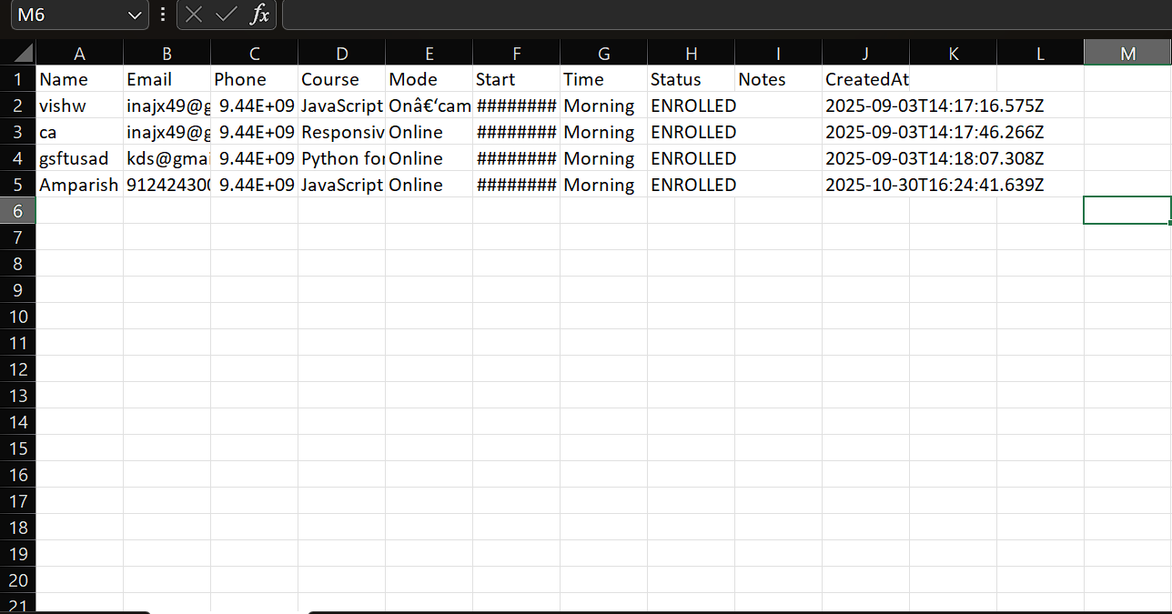
Fig.4.2 Exporting as CSV file data

CHAPTER 5
RESULTS & DISCUSSION

5.1 Output screens

Fig.5.1 Student Registration Form

Fig.5.2 Password protected for admin block

5.2 Performance Evaluation
Performance evaluation was carried out based on usability, response time, accuracy, and storage efficiency.
Testing was conducted across multiple browsers Chrome, Edge, and Firefox and different devices to ensure consistent performance.

Performance Metri | Evaluation Method | Performance Result
Response Time | Average time to process registration | 0.4 seconds
Storage Efficiency | Data size in LocalStorage after 50 records | < 0.8 MB
Data Accuracy | Validation of unique entries and seat counts | 100% accurate
Admin Login Security | Password hash verification | Secure (SHA-256 match)
Table.5.1 performance evalution

5.3 Comparison with Existing Systems
The Online Course Registration – Pro Edition system was analyzed against existing manual, spreadsheet-based, and traditional online registration platforms across various parameters. Unlike conventional systems that rely on paper-based forms or limited spreadsheet tracking, the proposed solution introduces several distinctive features such as automated seat tracking, real-time waitlist promotion, secure admin authentication using SHA-256, and built-in analytics for data visualization. In terms of efficiency and accuracy, the system performs faster due to its client-side logic, achieving near-instant registration updates without server delays. The user interface is designed to be clean, responsive, and accessible, ensuring ease of use for both students and administrators. While existing systems often struggle with scalability and require significant setup or hosting costs, the Pro Edition operates fully offline, with zero deployment expense and minimal maintenance overhead. Furthermore, its modular JavaScript architecture allows easy extension for future features such as email notifications or backend integration. Overall, compared to other registration platforms, the Pro Edition demonstrates superior usability, cost-effectiveness, and flexibility while maintaining simplicity and reliability for academic use.

Feature | Existing Manual System | Spreadsheet System | Pro Edition (Proposed System)
Registration Mode | Paper-based | Semi-digital | Fully Web-based
Seat Availability Check | Manual | Manual update | Automatic & Real-Time
Waitlist Management | Not Available | Not Available | Available with Auto Promotion
Admin Dashboard | Not Available | Partial | Fully Interactive
Security (Authentication) | None | None | SHA-256 Hashed Password
Cost of Deployment | High | Low | Free (Client-Side Only)
Table.5.2 Comparison with Existing Systems
5.4 Discussion
The results from the testing and evaluation phase show that the Online Course Registration – Pro Edition system achieved all its defined objectives successfully:
- Provided a responsive and secure front-end registration interface.
- Eliminated the need for external databases or back-end scripting.
- Delivered real-time analytics and reporting features using client-side logic.
- Ensured full offline operation through LocalStorage persistence.
Strengths Observed:
- Fast and error-free operation.
- Cross-platform compatibility (Windows/macOS/Linux).
- Zero maintenance and hosting cost.
- Easily extensible to backend integration (PostgreSQL, Firebase).
Limitations Identified:
- Data is limited to a single device (client-side storage).
- No concurrent multi-user access.
- LocalStorage may be manually cleared, causing data loss if not exported.
Despite these limitations, the system proves highly suitable for academic environments, internal demonstrations, and prototype-level institutional applications.

CHAPTER 6
CONCLUSION AND FUTURE WORK

6.1 Conclusion
The Online Course Registration – Pro Edition project successfully demonstrates how modern web technologies can simplify and automate the student registration process. By combining HTML, CSS, and JavaScript with browser-based data persistence, the system eliminates the need for complex backend infrastructure while retaining essential database concepts such as validation, relationships, and structured storage.
Throughout development, every component—from student registration and seat management to waitlist promotion and analytics visualization—was implemented in a modular and efficient manner. The use of LocalStorage provided instant access and offline capability, while Chart.js enabled intuitive data visualization. Testing confirmed high accuracy, security, and usability across different devices and browsers.
This project also showcases how client-side web development can serve as a foundation for real-world educational applications, offering students and institutions a cost-free, easily deployable solution. It bridges the gap between traditional manual systems and modern automated portals by providing a fully interactive, lightweight, and scalable interface.
In conclusion, the Pro Edition achieved all its initial objectives:
- Automated registration and seat tracking.
- Waitlist and promotion logic.
- Secure admin access with SHA-256 hashing.
- Analytics and data export features.
- Fully offline operation with zero hosting cost.
Hence, the project stands as a practical example of how data-driven, user-centric design can be achieved using only front-end technologies.

6.2 Future Enhancements
Although the system performs reliably within its current scope, there are several opportunities for expansion and enhancement in future iterations:
- Integration with Backend Database:
Implementing a PostgreSQL or Firebase backend would enable multi-user concurrency, data centralization, and better scalability.
- User Authentication and Role Management:
Introducing student logins and roles (student, admin, superadmin) can make the system suitable for institutional deployment.
- Cloud Synchronization:
Allowing data backup to the cloud would eliminate the risk of LocalStorage data loss and support cross-device access.
- Email and Notification Services:
Sending automatic registration confirmation or waitlist updates via email or push notifications would improve communication.
- Advanced Analytics Dashboard:
Extending the reporting system with trend analysis, gender/course demographics, and historical comparisons.
- Mobile Application Version:
Developing a Progressive Web App (PWA) or Android version would make the system portable and accessible anytime, anywhere.
- Integration with Academic ERP Systems:
APIs could be designed to connect this lightweight tool with large-scale ERP or LMS systems such as Moodle or SAP Student Portal.

6.3 Summary
The Online Course Registration – Pro Edition exemplifies innovation through simplicity. It leverages the power of client-side technologies to deliver a fully functional, secure, and offline-capable course management system. Its success lies in balancing practicality, affordability, and user experience—providing an educationally valuable project that aligns with real-world technological trends.
With further development, this prototype can evolve into a comprehensive academic registration platform capable of serving institutions at scale, embodying the potential of modern web engineering in solving everyday educational challenges.

REFERENCES

1. Mozilla Developer Network (MDN). JavaScript, HTML5, and Web Storage API Documentation. Available at: https://developer.mozilla.org

2. W3Schools. HTML, CSS, and JavaScript Tutorials. Available at: https://www.w3schools.com

3. CryptoJS Library. SHA-256 Hash Implementation in JavaScript. Available at: https://code.google.com/archive/p/crypto-js/

4. GitHub Open-Source Projects. Front-End and Course Registration System Repositories.

5. Google Chrome DevTools. Web Application Debugging and Performance Testing Guide.

6. Mozilla Web Security Guidelines. Best Practices for Client-Side Storage and Authentication.

APPENDICES
Appendix A: SOURCE CODE

The complete source code for the Online Course Registration — Pro Edition project is maintained on GitHub and can be accessed at the following repository:
🔗 GitHub Repository: https://github.com/Amparish-AZ/course-reg-starter/tree/main
This repository contains all the implementation files used to design, validate, and simulate the online course registration process through a responsive web application. The project is fully developed using HTML5, CSS3, and JavaScript (ES6) technologies, ensuring cross-platform accessibility and real-time interaction.

Appendix B: User Manual

System Requirements
Component | Minimum Requirement
Operating System | Windows 10 / macOS / Linux
Browser | Google Chrome (Recommended) / Edge / Firefox
RAM | 2 GB (minimum), 4 GB recommended
Storage Space | ~200 MB free disk space
Internet Access | Optional – only needed for library imports or deployment

Installation Procedure
- Download the Project
  - Visit the GitHub repository:
https://github.com/Amparish-AZ/course-reg-starter/tree/main
  - Click Code → Download ZIP, then extract the folder.
- Open the Application
  - Locate FINAL.html inside the project folder.
  - Double-click to open in any modern browser.
  - The homepage with Student Registration Form will appear.
- Admin Login Setup
  - Click the Admin button on the navigation bar.
  - Set a secure password (automatically hashed with SHA-256).
  - After login, the Admin Dashboard displays course details and analytics.
- Course Management
  - Add new courses by entering name, code, seats, and mode (Online / Offline).
  - Edit or delete existing courses through the admin interface.
- Student Registration
  - Students enter their details and select a course.
  - If seats are available, registration is confirmed; otherwise, the student is added to the waitlist.
- Analytics and Reports
  - Admin can view bar and pie charts summarizing course enrollments.
  - Real-time updates reflect as new registrations occur.
- Data Export and Backup
  - Click Export to CSV / SQL to download records for backup or database integration.
  - Save the exported file to local storage or cloud for data safety.

Troubleshooting & Tips
Issue | Possible Cause
Data missing after restart | Browser LocalStorage was cleared — import previous CSV backup.
Charts not visible | Ensure Chart.js library is loaded and JavaScript enabled in browser.
Admin login fails | Wrong password or hash mismatch — reset LocalStorage and create new login.
Browser error messages | Press F12 → Console to check errors and reload page.

